**Lab Report #04**

**Experiment Name #** Process in Linux OS.

**Aim and Objective:**

The purpose of the experiment is to learn how process works in Linux operating system. That is how user can list all the working process and kill any process.

* To learn about various process commands.
* To see the list of working process.
* To kill any process
* To get the best of Linux operating system.

**Experiment:**

**Ps aux :**

This command is used to show all the working process that is the detail running the system, process id(PID) and name of process. Through this command one can get necessary information of all process of a system.

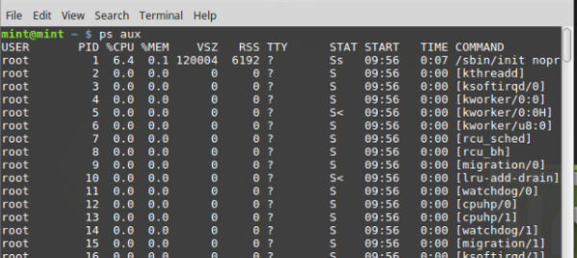

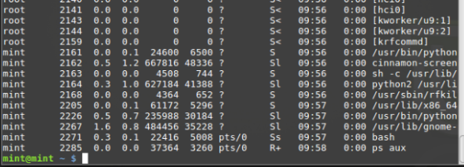

Here we can see user, PID, name of process, stat, time, command everything.

**Kill PID/ kill all/xkill :**

Here kill pid is used to kill a specific process of the system. It only kills the user processor. Kill all program_name kills the named processor and xkill is a GUI way to kill windows. It kills everything in and out.

**Kill PID:**

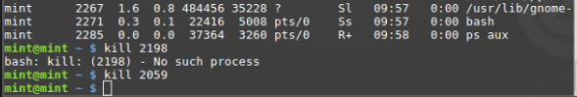

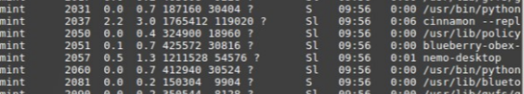

**Conclusion:**

Through this experiment of executing different commands I learn the basic commands for process of Linux operating system. I use ps aux command and kill PID to execute various process operations. This is one of the finest applications one can done in linux operating system.